**Patient Management System for Clinics/Hospitals**

**Project Overview: MediCare Connect**

**Industry:** Health-care

**Business Problem:** Healthcare providers struggle with fragmented patient data, inefficient appointment scheduling, poor communication between care teams, and lack of automated workflows, leading to reduced patient satisfaction and operational inefficiencies.

**Solution:** A comprehensive Salesforce-based Patient Management System that centralizes patient information, automates key workflows, ensures HIPAA compliance, and improves care coordination.

**🔍 Phase 1: Problem Understanding & Industry Analysis**

1. **Digital Transformation in Healthcare** – 78% of organizations are shifting from paper-based to digital tools, making Salesforce CRM vital for efficiency and competitiveness.
2. **Fragmented Data Systems** – Multiple disconnected systems cause incomplete records, delays, and errors, as seen in Techi Tales’ current setup.
3. **Communication Gaps** – Lack of real-time information sharing among staff compromises patient safety and treatment coordination.
4. **Administrative Overload** – Excess paperwork and system-switching reduce time for direct patient care, lowering quality and satisfaction.
5. **Rising Patient Expectations** – Patients demand personalized, coordinated, and easily accessible healthcare services with tailored interactions.
6. **Security & Compliance Needs** – Strict regulations (HIPAA) require secure, compliant CRM integration with encryption, access controls, and monitoring.

**🗺️Business Process Mapping**

**1. Patient Onboarding & Registration**

* **Start Trigger:** Patient seeks services (call, walk-in, online portal)
* **Sub-Processes:**
  + Collect patient demographic and contact details
  + Gather insurance and emergency contact information
  + Assess privacy consent and healthcare compliance acknowledgement
  + Create patient record (Patient__c object linked to Contact)
* **Key Outputs:**
  + New Patient Record
  + Insurance Data Captured
  + Confirmation Notification to patient

**2. Appointment Scheduling**

* **Start Trigger:** Patient requests appointment (phone/online)
* **Sub-Processes:**
  + Verify eligibility and doctor availability
  + Schedule appointment via Appointment__c object
  + Send confirmation email/SMS (automated workflow)
  + Reminder notifications (24hr/1hr before)
* **Key Outputs:**
  + Appointment Record (time, doctor, location, purpose)
  + Notification to patient and provider

**3. Care Delivery & Medical Record Update**

* **Start Trigger:** Patient arrives for appointment
* **Sub-Processes:**
  + Patient check-in
  + Provider reviews medical history
  + Document examination, diagnosis, treatment plan (Medical_Record__c update)
  + Prescription created if required
  + Record follow-up needs and schedule next appointment
* **Key Outputs:**
  + Updated Medical Record
  + New Prescription Record
  + Task/Reminder for follow-up

**4. Prescription & Medication Fulfillment**

* **Start Trigger:** Provider prescribes medication
* **Sub-Processes:**
  + Enter prescription details into Prescription__c
  + Automated pharmacy notification (email/SMS workflow)
  + Patient receives prescription info/reminder
  + Tracking refill status (automated notifications)
* **Key Outputs:**
  + Prescription History
  + Pharmacy Communication
  + Patient Refill Reminders

**5. Insurance Claims & Billing**

* **Start Trigger:** Bill generated for services rendered
* **Sub-Processes:**
  + Validate insurance coverage
  + Prepare and submit Insurance_Claim__c
  + Record claim status changes (submitted, approved, rejected)
  + Notify admin and patient of claim outcomes
* **Key Outputs:**
  + Insurance Claim Record
  + Status updates
  + Billing/Payment receipt

**6. Patient Feedback & Satisfaction**

* **Start Trigger:** Appointment complete, discharge or periodic survey
* **Sub-Processes:**
  + Feedback form sent automatically (workflow, portal, email)
  + Patient fills feedback (linked to Patient_Feedback__c object)
  + Data aggregated in dashboards for care quality review
* **Key Outputs:**
  + Feedback records
  + Performance and satisfaction analytics

**7. Compliance, Data Security, & Auditing**

* **Start Trigger:** Any patient data interaction (creation/update/access)
* **Sub-Processes:**
  + Enforce role-based and field-level security
  + Log data access events
  + Schedule regular data backup and archiving
  + Monitor for suspicious activity and ensure HIPAA compliance
* **Key Outputs:**
  + Audit Trail
  + Compliance Reports
  + Secure records

**8. Reporting & Analytics**

* **Start Trigger:** Periodic (daily/monthly/quarterly) or ad-hoc reporting
* **Sub-Processes:**
  + Generate patient demographics, appointments, treatment outcomes reports
  + Visualize data via dashboards (attendance, feedback, claims)
  + Share actionable insights with management
* **Key Outputs:**
  + Management Dashboards
  + Analytical Reports

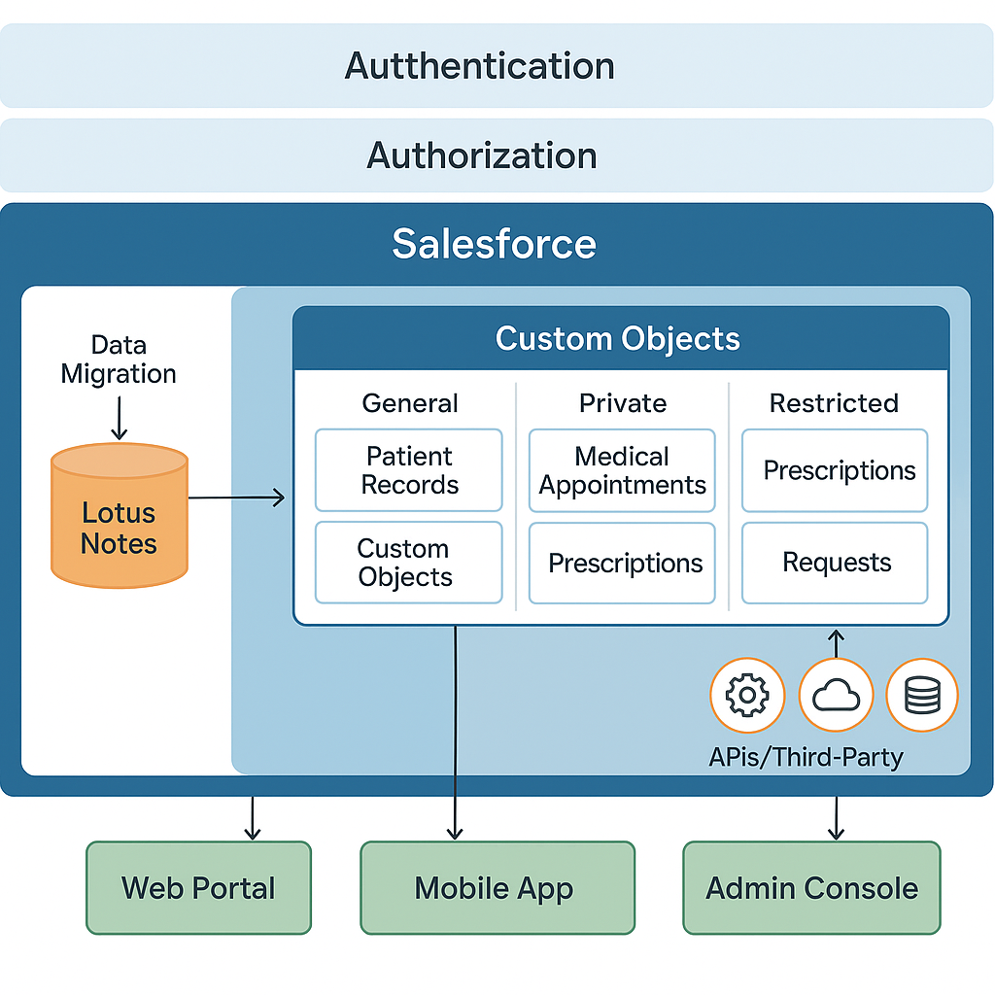

**High-Level Flow Outline**

1. **Patient registers → Appointment scheduled → Consult occurs → Medical & prescription record updated → Claim submitted → Feedback collected → Reports generated**
2. **Automations:** Email/SMS notifications, reminders, prescription refills, survey invites, escalation for approvals.
3. **Security:** Data access verified at every step, field and record-level security enforced.
4. **Audit:** All record changes, accesses, and integrations are logged for compliance.

📊 **Industry Impact Statistics**

* 20% improvement in patient outcomes through data-driven decisions (Deloitte report)
* 15% reduction in data breaches with centralized systems (Cybersecurity Insiders)
* 30% growth expected in digital health investments (Accenture report)

**Key Learning Objectives:**

• Understand healthcare industry challenges and patient management pain pointscapminds+1

• Learn HIPAA compliance requirements for healthcare datatntra+1

• Analyze stakeholder needs (patients, doctors, nurses, administrators)